Socio-economic situation of Mazowieckie Voivodship in March 2026
- In March this year, the average employment in the enterprise sector decreased both on a yearly and on a monthly basis by 0.2%. The registered unemployment rate amounted to 4.5% and increased on an annual basis (by 0.3 pp), and remained unchanged on a monthly basis.
- Average monthly gross wages and salaries in the enterprise sector in March this year were higher by 6.6% compared to the previous year and by 8.3% than in the previous month.
- On the agricultural market in March 2026, the average procurement prices of wheat, rye, potatoes, pigs and poultry for slaughter, as well as milk were lower than in the previous year, however the price of cattle for slaughter was higher. On a monthly basis, prices of all agricultural products in question increased, except for milk.
- In March this year, sold production of industry (at constant prices) increased on a yearly basis (by 15.9%), and on a monthly basis (by 18.4%). Construction and assembly production (at current prices) was smaller by 5.9% than in the previous year and by 31.3% larger than a month earlier.
- The number of dwellings completed in March this year, was larger by 11.5% than a year before and by 5.6% compared to the previous month. Most dwellings were built for sale or rent.
- In March this year, there was an increase in retail sales in annual terms (by 17.4%). Wholesale was also higher than in the previous year (by 23.4%).
- In March this year, the number of entities of the national economy registered in the REGON register was higher by 3.4% than in the previous year and by 0.4% than in the previous month.
- In April of this year, the general business climate indicator in most of the surveyed economic sectors indicated either stabilisation or a deterioration in economic conditions compared to the previous month. The largest decline in the indicator (by 3.1) was recorded in the accommodation and catering sector. A noticeable improvement in business conditions was observed only in retail trade, with the indicator increasing by 2.1 compared to March of this year. Only entities operating in transportation and storage express pessimistic assessments, and the indicator value is below the long-term average. Entrepreneurs involved in accommodation and catering express the most favourable opinions, and the indicator value is above the long-term average.

Contents
Labour market 4
Wages and salaries 7
Agriculture 9
Industry and construction 12
Residential construction 14
Internal market 16
Entities of the national economy 17
Business tendency 19
Selected data on Mazowieckie Voivodship 25

General notes
Data presented in the news release:
- on employment, wages and salaries and sold production of industry and construction, construction and assembly production, as well as retail sales and wholesale concern economic entities employing more than 9 persons,
- on enterprise sector refer to entities conducting economic activity in the field of: forestry and logging; maritime fishing; mining and quarrying; manufacturing; electricity, gas, steam and air conditioning supply; water supply; sewerage, waste management and remediation activities; construction; wholesale and retail trade; repair of motor vehicles and motorcycles; transportation and storage; accommodation and food service activities; information and communication; real estate activities; legal and accounting activities; activities of head offices; management consultancy activities; architectural and engineering activities; technical testing and analysis; advertising and market research; other professional, scientific and technical activities; arts, entertainment and recreation; repair of computers and personal and household goods; other personal service activities,
- on retail prices of foodstuffs and non-foodstuffs as well as services that originate from quotations of prices conducted by interviewers at selected points of sale in selected regions of price surveys; prices of food are collected once a month, with the exception of fruit and vegetables, for which prices are collected twice a month,
- on procurement of agricultural products include procurement from producers from the voivodship; prices are given excluding VAT tax,
- on financial results of enterprises and investment outlays refer to economic entities keeping accounting ledgers (excluding entities whose activity is classified according to the NACE Rev. 2 in the sections “Agriculture, forestry and fishing” and “Financial and insurance activities” as well as higher education institutions) in which the number of employed persons exceeds 49.
Data in value terms are provided at current prices and form the basis for calculating the structure indicators. Dynamic indices are provided on the basis of value at current prices, except for industry, for which the dynamic indices are provided on the basis of value at constant prices (average current prices of 2015).
Relative numbers (indices, percentages) were calculated on the basis of absolute data expressed with higher precision than that presented in the text and tables.
Data have been presented in accordance with the Polish Classification of Activities – PKD 2007 (NACE Rev. 2).

Polish Classification of Activities 2007 (PKD 2007)
Abbreviation | Full name
sections
trade; repair of motor vehicles | wholesale and retail trade; repair of motor vehicles and motorcycles
accommodation and catering | accommodation and food service activities
divisions
trade; repair of motor vehicles | wholesale and retail trade; repair of motor vehicles and motorcycles

Symbols
Symbol | Description
(–) | – magnitude zero
(.) | – data not available, classified data (statistical confidentiality) or providing data impossible or purposeless
(*) | – data revised
∆ | – categories of applied classification are presented in abbreviated form
„Of which” | – indicates that not all elements of the sum are given
Data describing Mazowieckie Voivodship can also be found in statistical publications issued by the Statistical Office in Warszawa and in the publications of Statistics Poland.
The report „Economic situation in Mazowieckie Voivodship in April 2026” was published on the home page of the Statistical Office in Warszawa:: https://warszawa.stat.gov.pl/ on 29 April 2026.
When publishing Statistical Office data, please indicate the source.

Labour market
In March this year, the average employment in the enterprise sector was lower compared to the previous year and compared to the previous month. The registered unemployment rate increased year-on-year and did not change month-on-month.
Average employment in the enterprise sector in March this year amounted to 1,569.5 thousand persons (full-time equivalent) and was by 0.2% lower in annual terms (in the previous month by 0.3%). The most significant decrease was recorded in real estate activities (by 2.3%), and also in transportation and storage (by 1.6%), manufacturing (by 0.7%) and in trade; repair of motor vehicles (by 0.5%). The highest increase was recorded in accommodation and catering (by 2.0%), followed by, among others, construction (by 1.7%), professional, scientific and technical activities (by 1.6%), and administrative and support service activities manufacturing (by 0.2%).
In comparison with February this year, average employment decreased by 0.2%. The most in administrative and support service activities (by 2.2%), and also, among others, in electricity, gas, steam and air conditioning supply (by 1.1%), accommodation and catering (by 0.4%), transportation and storage (by 0.2%). The increase was recorded in construction (by 0.5%) and manufacturing (by 0.1%).
Table 1. Average employment in the enterprise sector in February 2026
SPECIFICATION | 03 2026 |  | 01–03 2026
SPECIFICATION | In thousands | 03 2025=100 | In thousands | 01–03 2025=100
TOTAL | 1569,5 | 99,8 | 1572,1 | 99,6
of which:
Industry | 398,3 | 99,6 | 397,9 | 99,5
of which:
manufacturing | 356,7 | 99,3 | 356,3 | 99,2
electricity, gas, steam and air conditioning supply | 20,1 | 99,8 | 20,2 | 100,0
Construction | 95,2 | 101,7 | 94,8 | 101,4
Trade; repair of motor vehicles Δ | 325,3 | 99,5 | 325,5 | 99,4
Transportation and storage | 258,0 | 98,4 | 258,4 | 97,3
Accommodation and catering Δ | 35,0 | 102,0 | 35,1 | 102,8
Information and communication | 137,9 | 100,1 | 138,2 | 100,3
Real estate activities | 28,4 | 97,7 | 28,4 | 97,9
Professional, scientific and technical activities a | 116,6 | 101,6 | 116,6 | 101,7
Administrative and support service activities | 136,5 | 100,2 | 139,0 | 100,6
a Excluding divisions: Research and experimental development work and Veterinary activities.
In January-March of this year, average employment in the enterprise sector amounted to 1,572.1 thousand persons and decreased by 0.2% compared to the same period of 2025 (a year ago, the decrease was 1.4%).

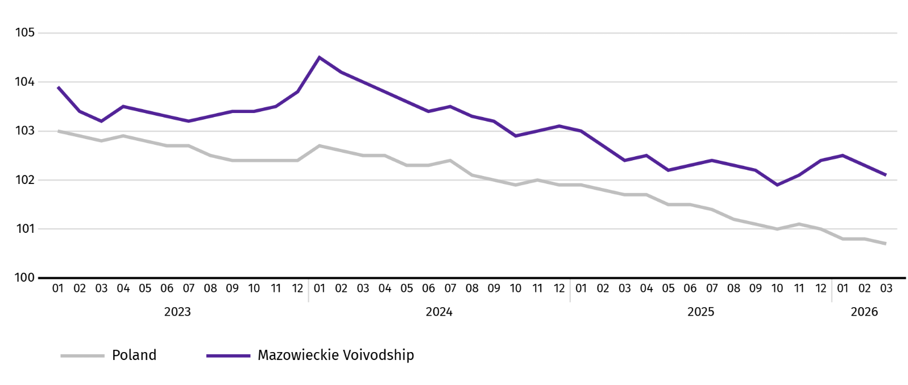
Chart 1. Average employment in the enterprise sector (monthly average 2021=100)

At the end of March this year, the number of unemployed persons registered in labour offices amounted to 124.7 thousand persons and increased on a yearly basis by 10.8 thousand persons (i.e. by 9.5%), and on a monthly basis decreased by 0.2 thousand persons (i.e. by 0.2%). Women accounted for 46.5% of total registered unemployed persons (a year before 47.7%).
Table 2. Number of unemployed persons and unemployment rate
SPECIFICATION | 2025 | 2026
SPECIFICATION | 03 | 02 | 03
Registered unemployed persons (as of end of month) in thousands | 113,9 | 124,9 | 124,7
Newly registered unemployed persons (during a month) in thousands | 12,6 | 12,9 | 12,6
Unemployed persons removed from unemployment rolls (during a month) in thousands | 14,7 | 10,6 | 12,9
Registered unemployment rate (as of end of month) in % | 4,2 | 4,5 | 4,5
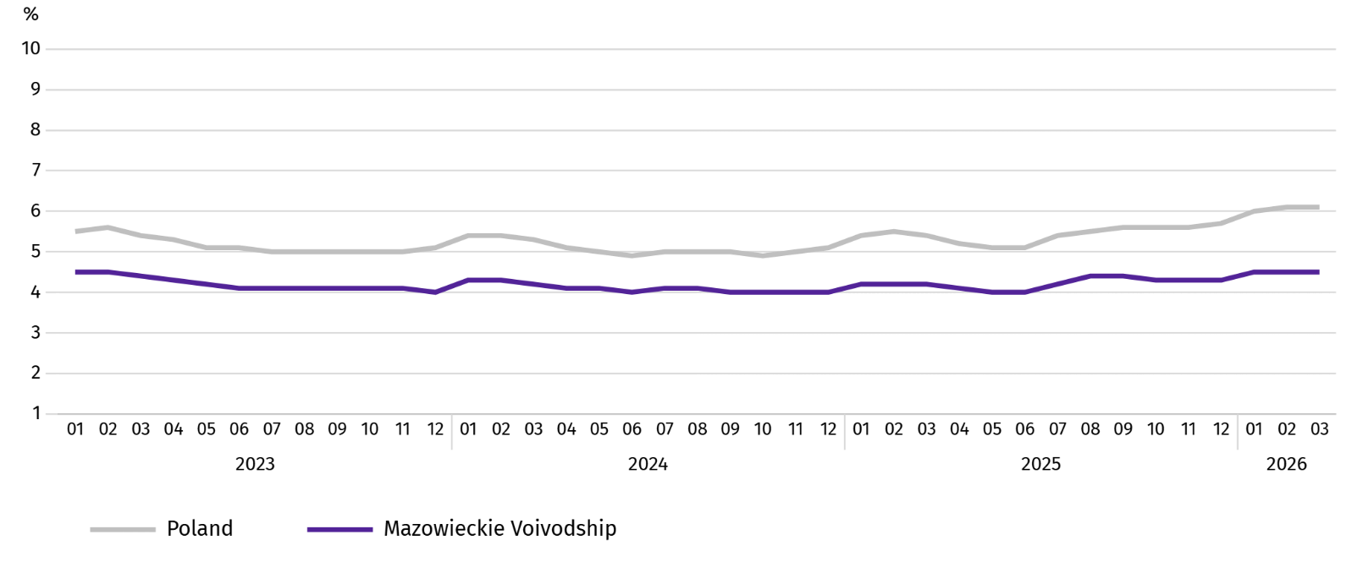
Chart 2. Registered unemployment rate (as of end of month)
Registered unemployment rate at the end of March this year amounted to 4.5% and was lower than the national average (6.1%). It increased on a yearly basis (0.3 pp), and did not change on a monthly basis.
The territorial differentiation of the unemployment rate continued in the Voivodship. Powiats with the highest unemployment rate were still szydłowiecki (22.7% against 23.0% in March last year), przysuski (18.5% compared to 18.6%), and radomski (17.3% against 16.6%), and with the lowest – Warszawa (1.6% against 1.4%), warszawski zachodni (2.0% against 1.8%) and pruszkowski (2.8% against 2.3%).
Compared to March last year, the unemployment rate increased in 37 out of 42 powiats. The highest increase was recorded in the powiats: gostyniński (by 1.7 pp), pułtuski (by 1.5 pp) and wołomiński (by 1.4 pp). The decrease was recorded in szydłowiecki powiat (by 0.3 pp), ciechanowski (by 0.2 pp) as well as kozienicki and przysuski (by 0.1 pp each).
Compared to February this year, the decrease in unemployment rate of 0.1-0.5 pp took place in 20 powiats. The increase of 0.1-0.2 pp took place in 7 powiats.
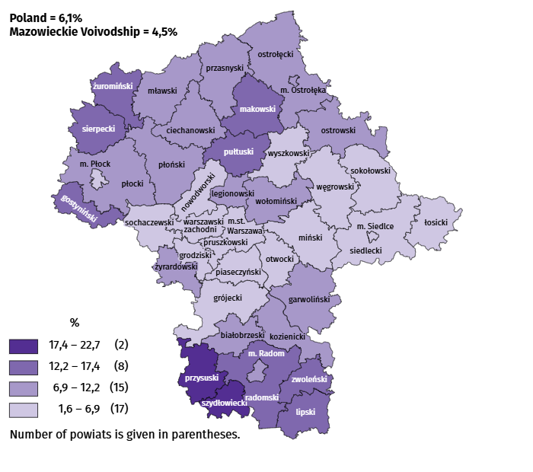
Map 1. Registered unemployment rate by powiats in 2026 (as of end of March)

In March this year, 12.6 thousand unemployed persons were registered in labour offices, i.e. more by 0.1% than a year before and less by 1.9% than in the previous month. Among the newly registered, 70.4% were persons registering for the second time (74.2% in the previous year). Share of persons previously not employed amounted to 13.9% (an increase of 1.2 pp year-on-year), persons terminated for company reasons 4.1% (a decrease of 0.9 pp). Among newly registered unemployed persons, 35.6% lived in rural areas (a decrease of 3.9 pp). Graduates accounted for 6.6% of newly registered unemployed persons (a decrease of 0.2 pp).
In March this year, 12.9 thousand persons were removed from unemployment rolls, i.e. less by 12.2% than a year before and more by 21.7% than a month before. 8.0 thousand persons (4.3% more than a year before) were removed from unemployment rolls due to undertaking employment. The share of this category of persons in the total number of persons removed from unemployment rolls increased by 9.8 pp on a yearly basis and amounted to 62.0%. The share of persons who obtained retirement or pension rights increased as well (by 0.2 pp to 0.6%). However the percentage of persons who started training and employer sponsored traineeships decreased (by 10.1 pp to 4.7%) and persons who voluntarily gave up their status of the unemployed (by 0.6 pp to 4.8%).
At the end of March this year, 109.4 thousand unemployed persons were not entitled to the unemployment benefit, and their share in the total number of the registered unemployed was 87.7% (a 3.2 pp increase in annual terms).
At the end of the surveyed month, 63.0 thousand, i.e. 50.5% out of registered unemployed persons were the long-term unemployed . The number of unemployed persons under the age of 30 amounted to 28.1 thousand, which accounted for 22.5% of the total unemployed (of which persons under the age of 25 constituted 11.9%). Persons aged over 50 amounted to 33.9 thousand (27.2%). There were 34.6 thousand (i.e. 27.8% of the total unemployed) of unemployed persons with at least one child under 18 or a disabled child aged under 24. The number of disabled unemployed persons amounted to 5.8 thousand (i.e. 4.6%).
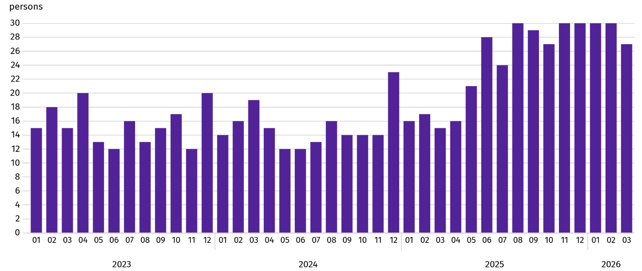
Chart 3. Registered unemployed persons per job offerª (as of end of month)

a From 1 June 2025, data on job offers are not fully comparable with earlier periods due to methodological changes resulting from the entry into force of the Act on the Labour Market and Employment Services (Journal of Laws of 2025, item 620).
In March this year, 5.5 thousand job offers were submitted to labour offices, i.e. more by 37.9% than in the previous month. At the end of month, there were 27 unemployed persons per job offer (36 a month before).
According to the labour offices, as of the end of March this year, 25 companies announced termination of 2.9 thousand employees in the near future (a year before, respectively 46 companies – 62.8 thousand employees).

Wages and salaries
In March this year, the average monthly gross wages and salaries in the enterprise sector increased on a yearly basis and compared to the previous month.
Average monthly gross wages and salaries in the enterprise sector in March this year amounted to PLN 11,502.04 and were higher than in the country (PLN 9,652.19). It increased by 6.6% on a yearly basis (by 6.1% in the previous month). The highest increase was recorded in electricity, gas, steam and air conditioning supply (by 23.7%), followed by, among others in real estate activities (by 8.7%), accommodation and catering (by 8.6%), manufacturing (by 8.5%).
In comparison with February this year, the average wages and salaries increased by 8.3%. The most significant increase concerned professional, scientific and technical activities (by 15.5%), followed by, among others, real estate activities (by 13.3%), information and communication (by 12.5%), accommodation and catering (by 11.0%).
Neither on a yearly nor monthly basis was there a decline in wages in any of the sections surveyed.
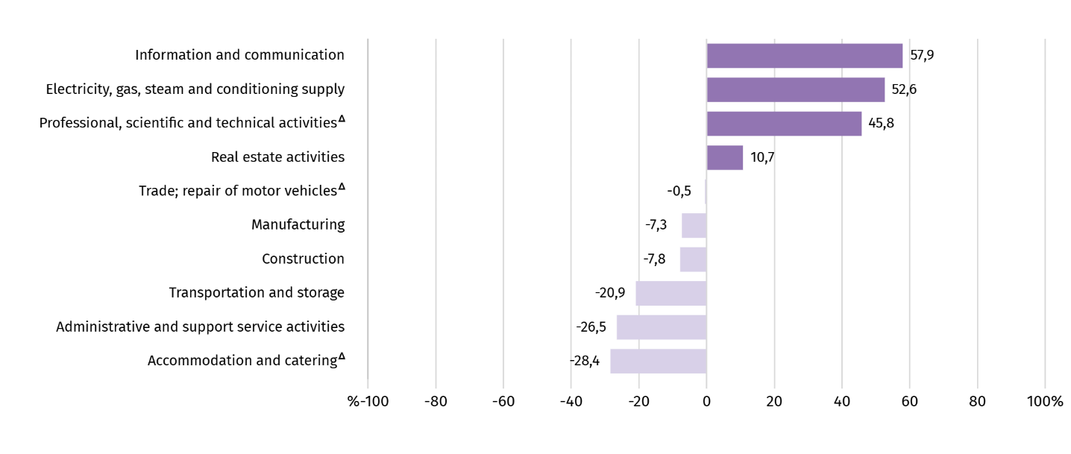
Chart 4. Relative deviations of average monthly gross wages and salaries in selected sections from average wages and salaries in the enterprise sector in March 2026

a Excluding divisions: Research and experimental development work and Veterinary activities.
Table 3. Average monthly gross wages and salaries in the enterprise sector in March 2026
SPECIFICATION | 03 2026 |  | 01–03 2026
SPECIFICATION | In PLN | 03 2025=100 | In PLN | 01–03 2025=100
TOTAL | 11502,04 | 106,6 | 10851,64 | 106,4
of which:
Industry | 10935,07 | 109,6 | 10315,01 | 107,0
of which:
manufacturing | 10660,28 | 108,5 | 9995,53 | 107,1
electricity, gas, steam and air conditioning supply | 17555,02 | 123,7 | 16920,03 | 104,1
Construction | 10609,80 | 106,8 | 10133,36 | 105,3
Trade; repair of motor vehicles Δ | 11448,41 | 105,6 | 10809,92 | 105,0
Transportation and storage | 9100,61 | 105,0 | 9030,78 | 106,4
Accommodation and catering Δ | 8236,52 | 108,6 | 7888,05 | 107,8
Information and communication | 18165,91 | 106,9 | 16541,11 | 108,0
Real estate activities | 12734,97 | 108,7 | 11595,69 | 109,1
Professional, scientific and technical activities a | 16768,02 | 104,3 | 15307,16 | 107,9
Administrative and support service activities | 8453,41 | 104,1 | 7976,33 | 102,6
a Excluding divisions: Research and experimental development work and Veterinary activities.
In the period January-March this year, the average monthly gross wages and salaries in the enterprise sector amounted to PLN 10,851.64 and was 6.4% higher than in the same period of 2025 (8.6% higher a year ago).
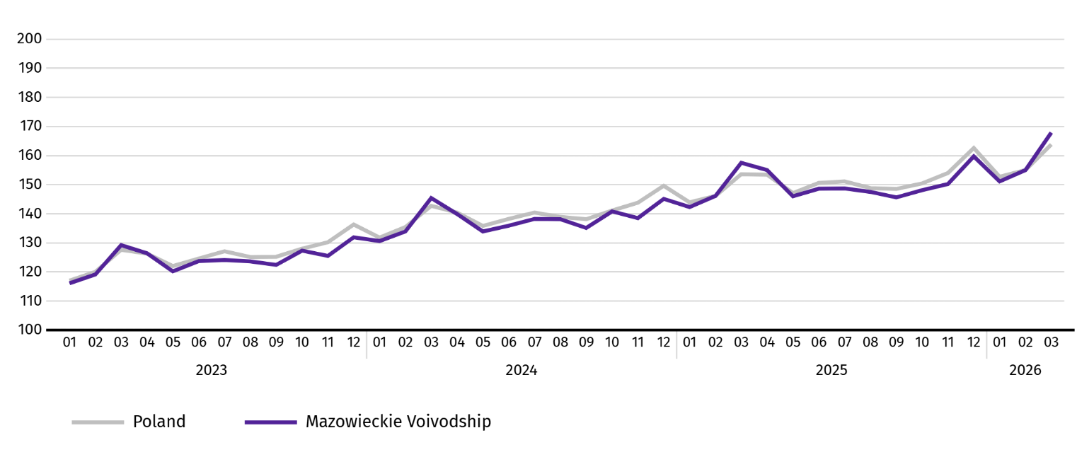
Chart 5. Average monthly gross wages and salaries in the enterprise sector (monthly average 2021=100)

Agriculture
On the agricultural market in March 2026, average procurement prices for wheat, rye, potatoes, pigs and poultry for slaughter as well as milk were lower than a year ago, while prices of cattle for slaughter were higher. On a monthly basis, more was paid for all agricultural products surveyed, except milk.
The average air temperature in Mazowieckie Voivodship in March 2026 amounted to minus 7.0°C and was by 4.2°C higher from the average from the years 1991–2020, while the maximum temperature reached 19.0°C, and the minimum amounted to minus 6.2°C (both values were recorded in Kozienice). The average atmospheric precipitation (7.5 mm) accounted for 23.4% of the standard for the multi-year periods (ranging from 8% in Warszawa to 45% in Kozienice). The number of days with precipitation, depending on the region, ranged from 3 to 7.
Table 4. Procurement of cerealsª
SPECIFICATION | 07 2025–03 2026 |  | 03 2026
SPECIFICATION | in thousand tonnes | analogiczny  okres roku  poprzedniego=100 | in thousand tonnes | 03 2025=100 | 02 2026=100
Grain of basic cereals b | 466,2 | 106,0 | 71,1 | 165,2 | 157,5
of which:
wheat | 360,7 | 109,8 | 61,8 | 177,9 | 163,1
rye | 40,3 | 94,1 | 4,1 | 98,4 | 169,0
a In January-March 2026, excluding procurement by natural persons. b Includes: wheat, rye, barley, oat, triticale; including cereal mixed, excluding sowing seed.
In July 2025-March 2026, the procurement of basic cereals (with cereal mixed, without sowing seed) was by 6.0% higher than in the same period of previous year, with procurement of wheat larger by 9.8%, and procurement of rye smaller by 5.9%. In March 2026, procurement of cereal was larger by 65.2% than a year ago and by 57.5% than in the previous month.

Table 5. Procurement of basic animal products ª
SPECIFICATION | 01–03 2026 |  | 03 2026
SPECIFICATION | in thousand tonnes | 01–03 2025=100 | in thousand tonnes | 03 2025=100 | 02 2026=100
Animals for slaughter ^{b} | 307,0 | 110,9 | 105,5 | 123,4 | 114,6
of which:
cattle (including calves) | 6,9 | 58,7 | 2,0 | 50,0 | 85,2
pigs | 59,5 | 99,4 | 21,1 | 124,3 | 118,3
poultry | 240,4 | 117,3 | 82,4 | 127,7 | 114,6
Milk ^{c} | 717,5 | 102,1 | 252,4 | 101,7 | 113,9
a Excluding procurement by natural persons. b Including cattle, calves, pigs, sheep, horses and poultry; in terms of meat including fats in post-slaughter warm weight. c In million litres.
Since the beginning of this year, producers in Mazowieckie Voivodship have supplied 307.0 thousand tonnes of animals for slaughter (in post-slaughter warm weight), which is 10.9% more than a year ago. The increase in procurement concerned poultry for slaughter (by 17.3%), while the decrease for cattle for slaughter (by 41.3%) and pigs for slaughter (by 0.6%). In March 2026, the supply of animals for slaughter was 23.4% higher than a year ago and 14.6% than a month ago.
Deliveries of milk in March this year (252.4 million litres) were by 1.7% larger than in the previous year and by 13.9% than in the previous month.
Table 6. Average procurement prices of basic agricultural products
SPECIFICATION | 03 2026 |  |  | 01–03 2026
SPECIFICATION | PLN | 03 2025=100 | 02 2026=100 | PLN | 01–03 2025=100
Wheat ª per dt | 78,19 | 85,0 | 101,7 | 77,76 | 83,6
Rye ª per dt | 63,01 | 87,4 | 102,5 | 62,56 | 87,5
Potatoes per dt | 127,66 | 92,1 | 137,0 | 105,12 | 76,9
Animals for slaughter per kg of live weight:
cattle (excluding calves) | 19,35 | 108,6 | 104,7 | 19,02 | 116,2
pigs | 6,12 | 92,6 | 114,0 | 5,52 | 88,6
poultry | 5,44 | 94,2 | 101,0 | 5,37 | 96,7
Milk per 1 hl | 183,61 | 80,3 | 97,5 | 187,15 | 81,8
a Excluding sowing seed.
In March 2026, PLN 78.19 was paid for 1 dt of wheat at procurement, i.e. 1.7% more than last month and less by 15.0% than last year. The average price of wheat at marketplaces was PLN 105.13 and was smaller by 1.5% than in February 2026, and by 7.9% than in March 2025. The procurement price of rye increased by 2.5% (to PLN 63.01) compared to the previous month, and the marketplace price decreased by 4.9% (to PLN 68.87). Compared to March 2025, procurement prices for rye were 12.6% lower, and marketplace prices by 13.6%.
Table 7. Average marketplace prices of wheat and potatoes
SPECIFICACATION | 03 2026 |  |  | 01–03 2026
SPECIFICACATION | PLN | 03 2025=100 | 02 2026=100 | PLN | 01–03 2025=100
Wheat per dt | 105,13 | 92,1 | 98,5 | 105,90 | 92,8
Rye per dt | 68,87 | 86,4 | 95,1 | 70,98 | 89,6
Potatoes b per dt | 174,30 | 77,9 | 94,2 | 181,25 | 81,0
a Edible late.
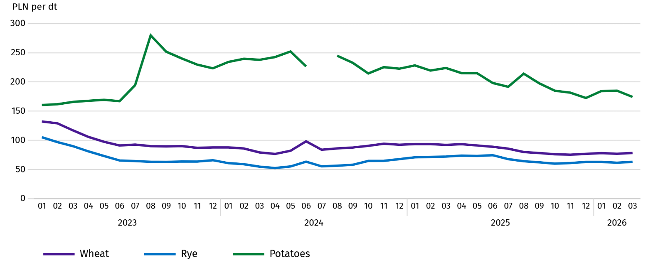
Chart 6. Average marketplace prices of cereals and potatoesª

a In July 2024, the price of late edible potatoes was not recorded due to their absence at the time of observations.
In March 2026, the average procurement price of potatoes was PLN 127.66/dt, i.e. more by 37.0% than in the previous month and less by 7.9% than last year. At marketplaces, the average price of 1 dt of potatoes was PLN 174.30 and was 5.8% lower than in the previous month, and by 22.1% than in the previous year.
Chart 7. Average procurement prices of animals for slaughter and milk
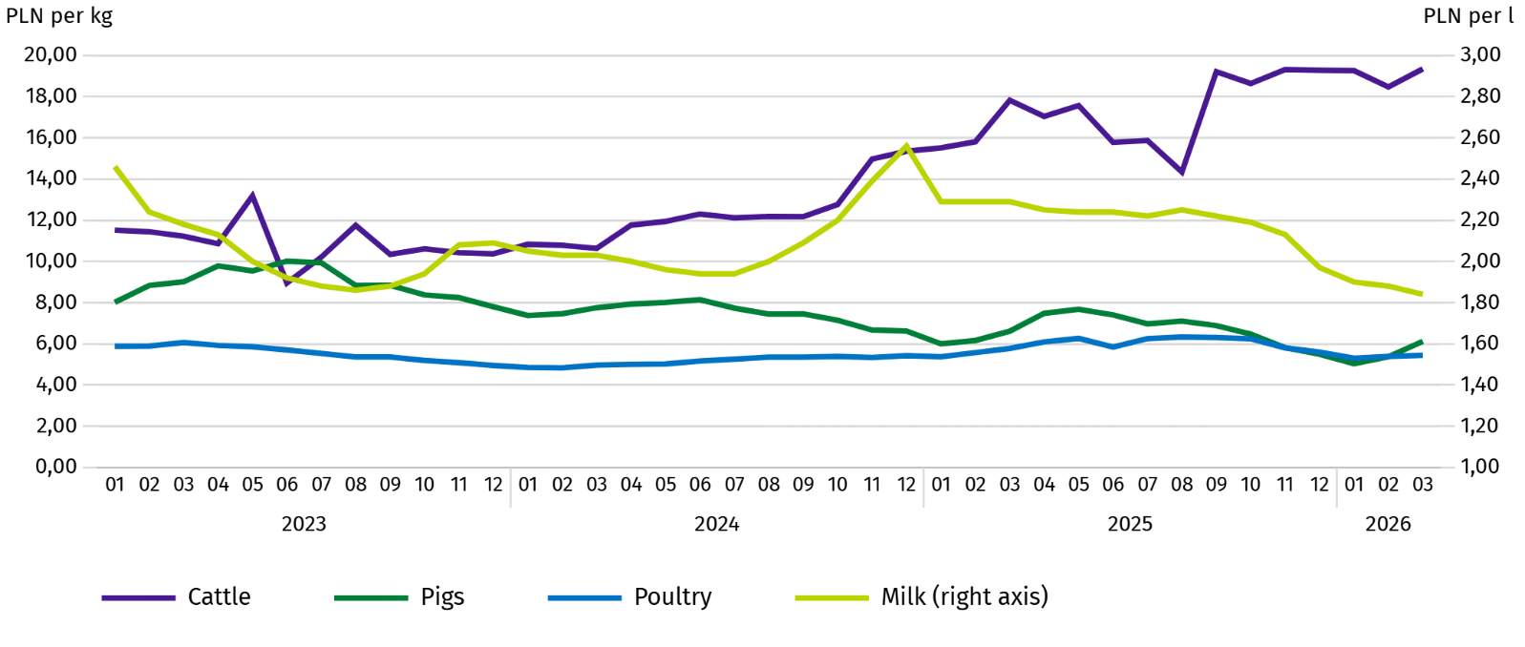
In March 2026, the average procurement price of pigs for slaughter was higher by 14.0% than in the previous month, and by 7.4% lower than In the previous year.
Chart 8. Ratio of the average procurement prices of pigs for slaughter to the average marketplace prices of rye
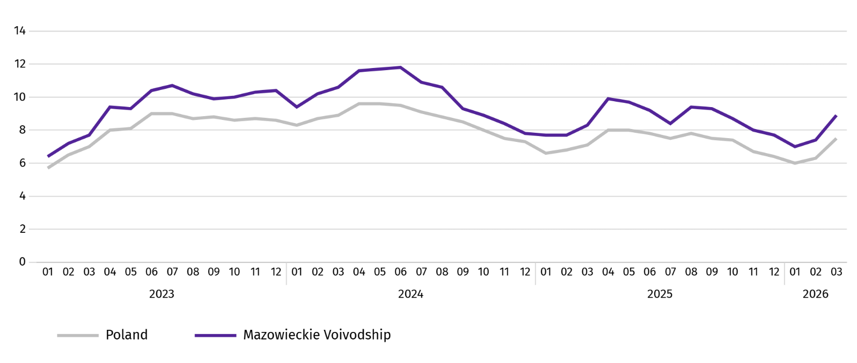
In March this year, the average procurement price of cattle for slaughter was by 4.7% higher than in the previous month and by 8.6% than in the previous year.
In March 2026, suppliers paid an average of PLN 5.44 per 1 kg of poultry for slaughter, i.e. 1.0% more than in February 2026 and 5.8% less than in March 2025.
Procurement prices of milk in March this year were by 2.5% lower than in the previous month and by 19.7% than in the previous year.

Industry and construction
Sold production of industry in March this year, reached the value (at current prices) of 50,973.2 million and was (at constant prices) by 15.9% higher than a year before (compared to a 4.5% increase in February this year); as compared to the previous month it increased by 18.4%.
Sold production in manufacturing (constituting 87.5% of sold production of industry) compared to March last year increased (at constant prices) by 16.8%. There was also an increase (by 3.7%) in sold production in the section of electricity, gas, steam and air conditioning supply (the share of this section represents 10.3% of industrial production).
Chart 9. Sold production of industry (monthly average 2021=100; constant prices)
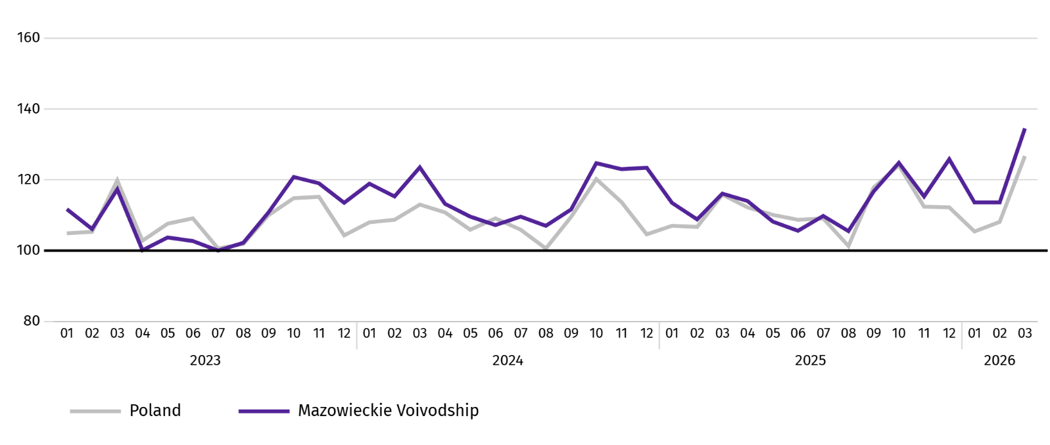
In March this year, the increase in sold production in annual terms was recorded in 27 (out of 32 in the Voivodship) divisions of industry, among others, in: manufacture of beverages (by 37.4%), manufacture of rubber and plastic products (by 16.2%), manufactue of food products (by 13.7%), manufacture of chemicals and chemical products (by 10.1%), manufacture of other non-metallic mineral products (by 9.4%), manufacture of metal products (by 5.0%), manufacture of paper and paper products (by 1.0%), electrical equipment (by 0.7%). However, there was a decrease in sold production of, among others, computer, electronic and optical equipment (by 14.9%), machinery and equipment n.e.c. (by 2.1%).
Table 8. Indices (constant prices) and structure (current prices) of sold production of industry in March 2026
SPECIFICATION | 03 2026 | 01–03 2026
SPECIFICATION | corresponding period of previous year=100 |  | In percent
TOTAL | 115,9 | 105,1 | 100,0
of which:
Manufacturing | 116,8 | 105,0 | 85,0
of which manufacture of:
food products | 113,7 | 109,0 | 21,1
beverages | 137,4 | 129,4 | 2,0
paper and paper products | 101,0 | 95,9 | 1,8
chemicals and chemical products | 110,1 | 103,0 | 3,9
manufacture of rubber and plastic products | 116,2 | 107,5 | 3,0
other non-metallic mineral products | 109,4 | 87,9 | 1,8
metal products ^{Δ} | 105,0 | 98,6 | 3,3
computer, electronic and optical equipment | 85,1 | 99,9 | 4,7
electrical equipment | 100,7 | 88,6 | 3,7
machinery and equipment n.e.c. | 97,9 | 105,7 | 1,8
Electricity, gas, steam and air conditioning supply ^{Δ} | 103,7 | 107,3 | 12,8
Labour productivity in industry measured by sold production per employed person, in March this year amounted (at current prices) to PLN 128.0 thousand and was (at constant prices) by 16.4% higher than a year before, with a decrease in average paid employment by 0.4% and an increase in average monthly gross wages and salaries by 9.6%.
In the January-March period of this year, sold production of industry amounted to PLN 136,782.5 million (at current prices) and was (at constant prices) 5.1% higher than in the same period of the previous year.
Sold production of construction (at current prices) in March this year, reached the value of PLN 8,988.0 million and was by 10.7% lower than in the previous year (compared to a 9.5% decrease in February this year). In January-March this year, sold production of construction amounted to PLN 23,648.1 million and was 11.2% lower compared to the corresponding period of previous year.
Labour productivity in construction, measured by revenue from the sale of goods and services per employed person in March this year amounted to PLN 94.4 thousand (at current prices) and was by 12.2% lower compared to the corresponding month of the previous year, with an increase in average employment in construction by 1.7% and in average monthly gross wages and salaries by 6.8%.
Construction and assembly production (at current prices) in March this year, amounted to PLN 2,224.0 million and was by 5.9% lower than a year before (as compared to 14.8% decrease in February last year). The decrease in production was recorded in units specialising in civil engineering (by 20.7%), in enterprises mainly performing specialised construction activities (by 13.0%). While an increase was recorded in entities whose basic activity is the construction of buildings (by 21.9%). In January-March of this year, construction and assembly production amounted to PLN 5,535.2 million and was by 11.2% lower compared to the corresponding period of previous year.
Table 9. Indices and structure (current prices) of construction and assembly production in March 2026
SPECIFICATION | 03 2026 | 01–03 2026
SPECIFICATION | corresponding period of previous year=100 |  | in percent
TOTAL | 94,1 | 88,8 | 100,0
Construction of buildings ^{Δ} | 121,9 | 101,3 | 35,0
Civil engineering | 79,3 | 80,2 | 36,4
Specialised construction activities | 87,0 | 87,4 | 28,6

Residential construction
In March this year, the number of dwellings completed increased by 11.5% compared to the corresponding month of 2025. The number of dwellings for which permits have been granted or which have been registered with a construction project increased by 3.2%, and dwellings in which construction has begun decreased by 4.5%.
According to preliminary data in March this year, there were 3,123 dwellings completed, i.e. by 321 more (by 11.5%) than in the previous year and by 167 (by 5.6%) than in the previous month. There were 2,106 dwellings built for sale or rent (67.4% of their total number), followed by private dwellings 917 (29.4%). Compared to March last year, there were more dwellings for sale or rent by 10.6%, and private dwellings by 7.0%.
The effects of housing construction obtained in Mazowieckie Voivodship in the surveyed month constituted 19.6% of national effects.
Table 10. Number of dwellings completed in January-March 2026
SPECIFICATION | Dwellings completed |  |  | Average useful floor area of a dwelling in m²
SPECIFICATION | In absolute numbers | in percent | 01–03 2025=100 | Average useful floor area of a dwelling in m²
TOTAL | 9062 | 100,0 | 93,6 | 90,1
Private | 2718 | 30,0 | 112,6 | 146,7
For sale or rent | 6244 | 68,9 | 88,6 | 66,3
Company | 100 | 1,1 | . | 35,6

Chart 10. Dwellings completed (corresponding period 2021=100)
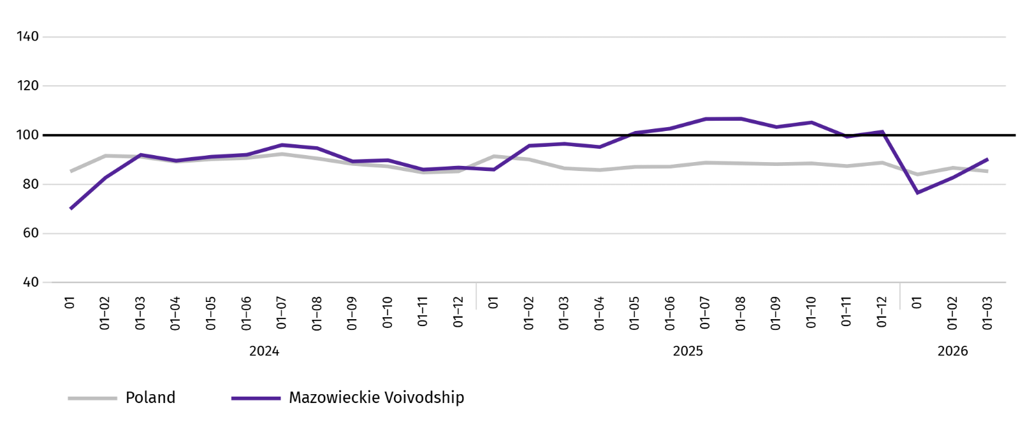
In January-March this year, most dwellings were completed in Warszawa (2620), and then in piaseczyński (630), wołomiński (577), and the least in Ostrołęka (5) and in łosicki (8) and lipski (11) powiats.
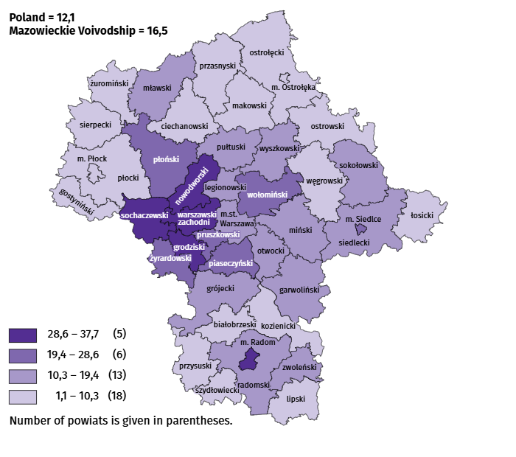
Map 2. Dwellings completed per 10 thousand populationa by powiats in January–March 2026

a Population as of 31 December 2025.
The average useful floor area of dwellings completed in March this year amounted to 83.8 m² and was smaller than a year earlier by 6.3 m² than a year earlier. The largest dwellings were completed in łosicki powiat (176.7 m²), siedlecki (158.2 m²) and sokołowski powiat (157.5 m²). The smallest were built in Siedlce (54.2 m²), Warszawa (56.2 m²) and in płoński powiat (58.0 m²).
In March this year, the number of dwellings for which permits have been granted or which have been registered with a construction project amounted to 3803, i.e. larger by 118 (by 3.2%) than a year earlier and smaller by 397 (by 9.5%) than in the previous month. Of the total number of dwellings, 63.0% were dwellings for sale or rent, and 35.6% private.
In the surveyed month, the construction began in 4654 dwellings, which means a decrease by 219 (by 4.5%) in annual terms and an increase by 2824 (by 154.3%) in monthly terms. Dwellings for sale or rent accounted for 68.3% of their total number, and private 31.7%.
Table 11. Number of dwellings for which permits have been granted or which have been registered with a construction project as well as dwelling in which construction has begun in January–March 2026
SPECIFICATION | Dwellings for which permits have been granted or which have been registered with a construction project |  |  | Dwellings in which construction has begun
SPECIFICATION | in absolute numbers | in percent | 01–03 2025=100 | in absolute numbers | in percent | 01–03 2025=100
TOTAL | 11395 | 100,0 | 98,3 | 9088 | 100,0 | 80,9
Private | 3323 | 29,2 | 113,3 | 2380 | 26,2 | 86,4
For sale or rent | 7965 | 69,9 | 93,8 | 6708 | 73,8 | 79,1
Municipal | 83 | 0,7 | 188,6 | – | – | .
Company | 24 | 0,2 | . | – | – | .

Internal market
In March this year, both retail and wholesale sales were higher than in the previous year.
Retail sales (at current prices) in trade and non-trade enterprises in March this year, increased by 17.4% compared to the year before. The increase in sales was recorded in units from the group: “other retail sales in non-specialised stores” (by 32.2%), “pharmaceuticals, cosmetics, orthopedic equipment” (by 24.4%), „others” (by 16.8%), “motor vehicles, motorcycles, parts” (by 12.0%), as well as “textiles, clothing and footwear” (by 8.7%), “newspapers, books, other sales in specialised stores” (by 2.0%), and “furniture, electronics and household appliances” (by 1.4%).
Compared to February this year, retail sales increased by 25.3%. The increase in retail sales was recorded in the following groups: “textiles, clothing and footwear” (by 34.6%), “furniture, electronics and household appliances” (by 26.6%), “motor vehicles, motorcycles, parts” (by 26.1%), “food, beverages and tobacco” (by 16.4%), “other retail sales in non-specialised stores” (by 15.9%), “others” (by 11.0%), as well as „pharmaceuticals, cosmetics, orthopedic equipment” (by 7.8%).
Table 12. Indices and structure (at current prices) of retail sales in March 2026
SPECIFICATION | 03 2026 | 01–03 2026
SPECIFICATION | corresponding period of previous year=100 |  | in percent
TOTAL ª | 117,4 | 109,4 | 100,0
of which:
Motor vehicles, motorcycles, parts | 112,0 | 105,7 | 7,3
Food, beverages and tobacco | 100,5 | 99,1 | 13,0
Other retail sales in non-specialised stores | 132,2 | 142,1 | 3,6
a The grouping of enterprises was made on the basis of the Polish Classification of Activities - PKD 2007, including the enterprise to a specific category according to the type of predominant activity, in accordance with the organizational status in the period under consideration. The recorded changes (increase/decrease) in retail sales in particular groups of activity of enterprises may also result from changes in the type of predominant economic activity and organisational changes (e.g. mergers of enterprises). This does not affect the dynamics of retail sales in general.
Table 12. Indices and structure (at current prices) of retail sales in March 2026 (cont.)
SPECIFICATION | 03 2026 | 01–03 2026
SPECIFICATION | corresponding period of previous year=100 |  | in percent
Pharmaceuticals, cosmetics and orthopedic equipment | 124,4 | 121,3 | 5,7
Textiles, clothing and footwear | 108,7 | 109,4 | 5,3
Furniture, electronics and household appliances | 101,4 | 100,8 | 16,2
Newspapers, books, other sales in specialised stores | 102,0 | 98,0 | 6,2
Others | 116,6 | 106,6 | 8,9
In January-March 2026, retail sales increased by 9.4% year-on-year. The largest sales increase was recorded by enterprises in the "other retail sales in non-specialised stores" group (by 42.1%), while the largest sales decline was recorded by enterprises in the „newspapers, books, other sales in specialised stores” group (by 2.0%).
Wholesale (at current prices) in trade enterprises in March this year was by 21.2% higher as compared to the previous month and by 23.4% higher compared to March 2025. In wholesale enterprises it was higher by 21.5% and by 20.5%, respectively.
In January-March 2026, trade enterprises achieved wholesale that was 15.7% higher than a year ago, and wholesale enterprises achieved wholesale that was 15.4% higher.

Entities of the national economy
In March this year, the number of national economy entities entered into the REGON register increased by 0.4% compared to the previous month. There were more entities removed from the register than a month ago as well as newly registered entities and entities (by 45.0% and 40.7%, respectively. Whereas there were less entities with suspended activity by 0.1%.
As of the end of March this year, 1097984 entities of the national economy were registered in the REGON register, i.e. by 3.4% more than last year and by 0.4% than in the previous month.
In the total number of registered entities, the greatest number is natural persons conducting economic activity. At the end of March this year, there were 706980 of them, i.e. more by 3.4% than in the previous year. The number of companies which were registered in the REGON register amounted to 309510, including 249824 commercial companies (an annual increase by 3.5% and 4.5%, respectively). There were 59225 civil partnerships i.e. less by 0.3% compared to the previous year.
According to the expected number of employed persons, entities that declared employment of up to 9 persons pre-vailed upon entry in the REGON register; they constituted 97.4% of all registered units. The share of entities with an estimated number of 10-49 employed persons was 2.1%, and of entities employing more than 49 persons – 0.5%. Over the year, the increase in the number of entities occurred among the smallest entities (up to 9 persons) – by 3.6%.
Compared to March 2025, the largest increase in the number of entities was recorded in the sections: professional, scientific and technical activities – more by 6862 units (in percentage terms, an increase of 4.2% compared to the pre-vious year), administrative and support service activities – by 5714 units (an increase of 10.9%), information and communication – by 5172 (an increase of 4.6%).
Compared to February this year, the largest increase in the number of entities was recorded in the sections: administrative and support service activities (by 1.2%), construction, human health and social work activities, activities of extraterritorial organisations and bodies (by 0.6% each), information and communication as well as education (by 0.5% each).

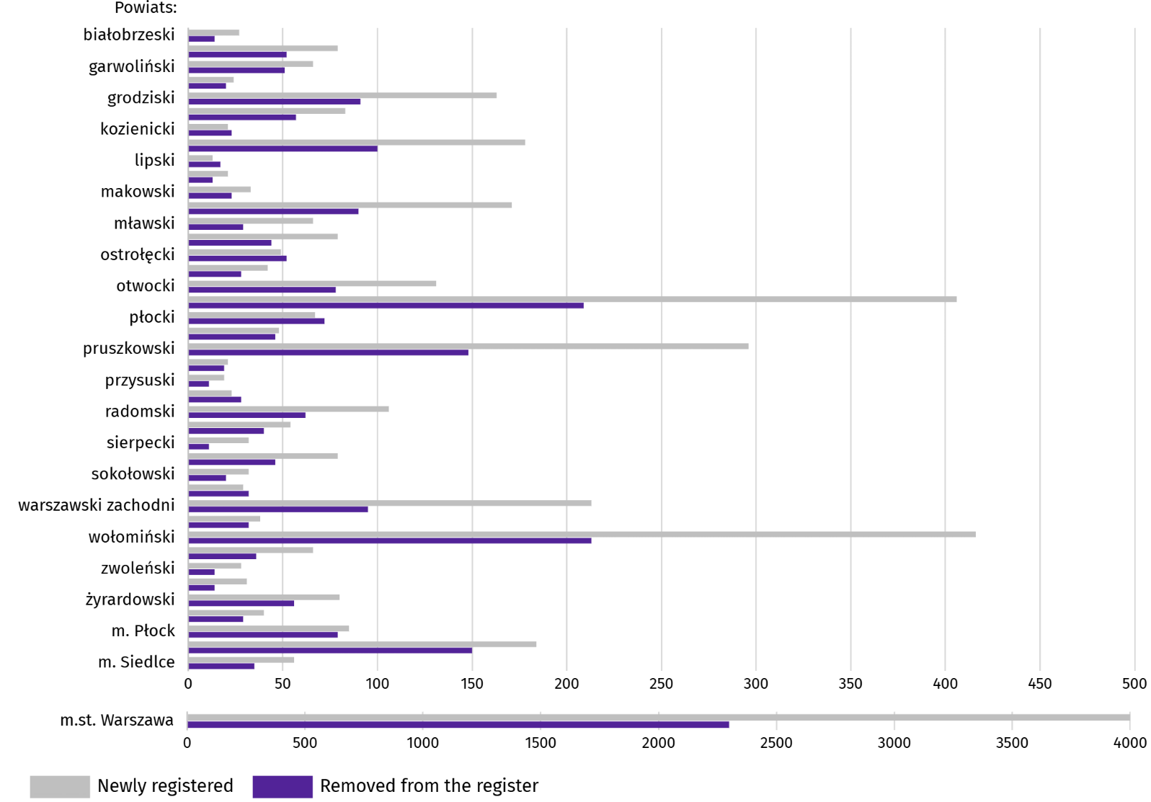
Chart 11. Entities of the national economy newly registered and removed from the register in March 2026

In March this year, 8558 new entities were entered in the REGON register, i.e. by 40.7% more than in the previous month. The newly registered units were dominated by natural persons conducting economic activity, 6369 of whom were registered (by 48.3% more than in the previous month). The number of newly registered commercial companies was higher by 21.9%, including companies with limited liability by 24.7%.
In the surveyed month, 4578 entities were removed from the REGON register (by 45.0% more than a month ago), including 3730 natural persons conducting economic activity (by 55.2% more).
As of the end of March this year, there were 152242 entities in the REGON with suspended activity (by 0.1% less than a month ago). The vast majority were natural persons conducting economic activity (93.8%; 93.9% in the previous month).

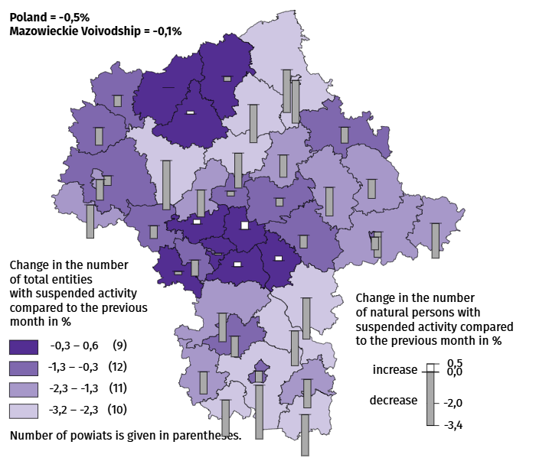
Map 3. Entities of the national economy with suspended activity in March 2026

Business tendency
In April of this year, the general business climate indicator in most of the surveyed economic sectors signals either stabilisation or a deterioration in economic conditions compared to the previous month. The largest decline in the indicator (by 3.1) was recorded in the accommodation and catering sector. A noticeable improvement in business conditions occurred only in retail trade, with the indicator increasing by 2.1 compared to March of this year. Only entities operating in transportation and storage express pessimistic assessments (minus 1.1), and the indicator value is below the long-term average (plus 5.2). Entrepreneurs involved in accommodation and catering express the most favourable opinions (plus 19.1), and the indicator value is above the long-term average (plus 1.0).

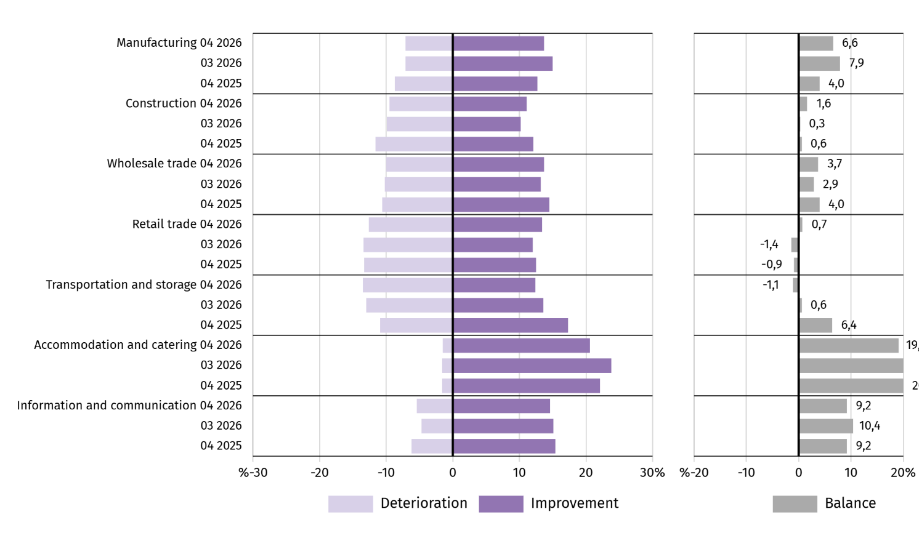
Chart 12. Indices of the general business climate by type of activity (sections and divisions of NACE Rev. 2)
Questions about the impact of the war in Ukraine
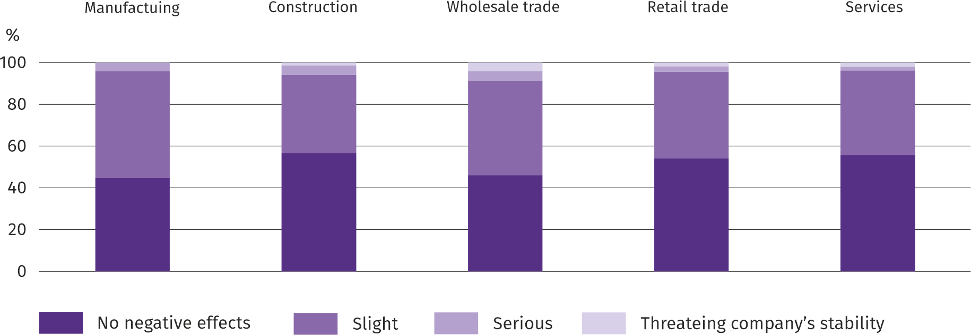
Question 1. The negative effects of the war in Ukraine and its consequences for your company's business activities will be:

In all the surveyed areas of the economy, entrepreneurs prevailed and answered that the ongoing war did not result in April this year. no negative effects or posed a slight threat to the conduct of their companies' economic activities. The effects of the war were serious and threatening to the stability of the company and were most often felt by entrepreneurs operating in wholesale trade, and least often in services.

Question 2. Of the negative effects of the war in Ukraine observed in the last month, the following are most relevant to your company:
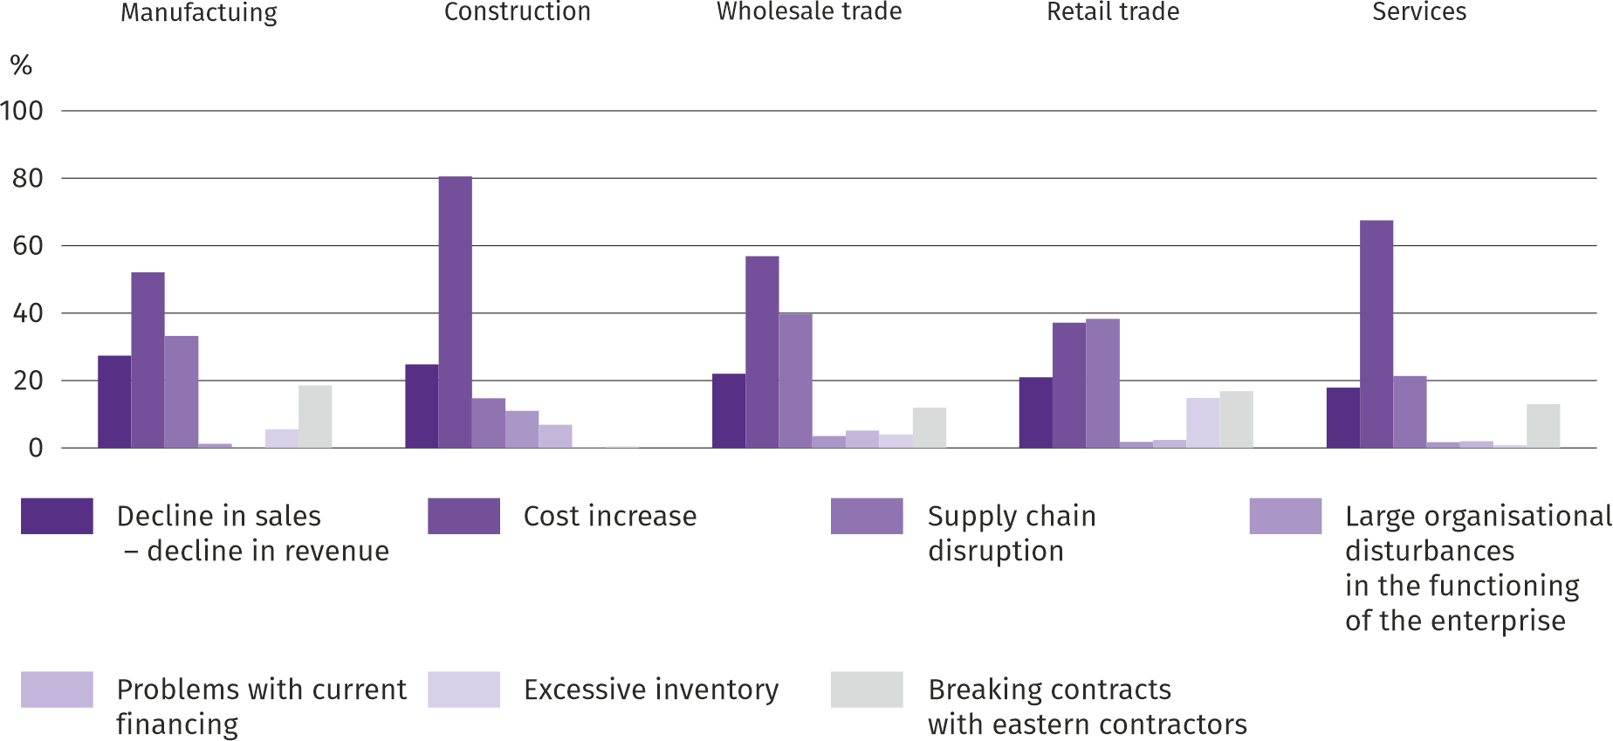
The most significant negative effect of the war in Ukraine was considered by entrepreneurs in most of the surveyed areas of activity to be an increase in costs, and in retail trade – a disruption in the supply chain.
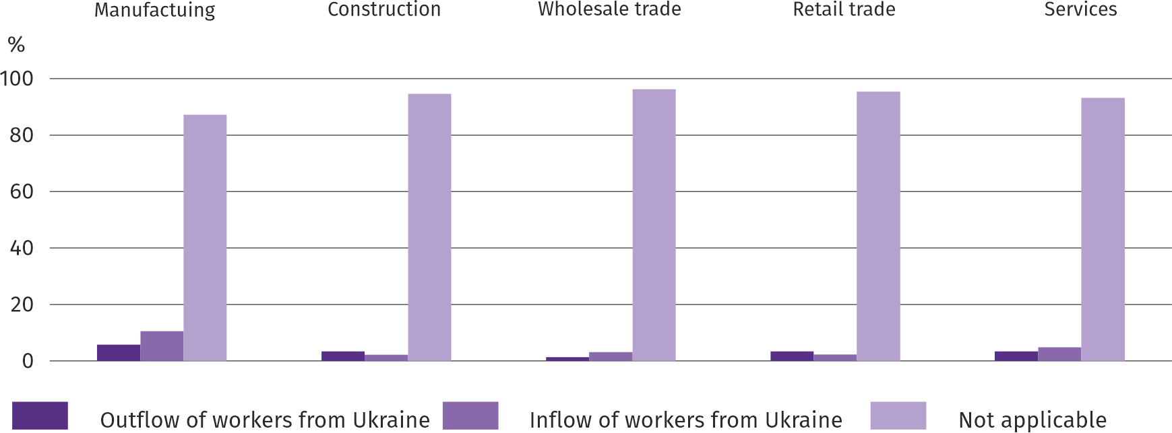
Question 3. If your company employs workers from Ukraine, have you observed the following in the last month due to the war in Ukraine:

In April of this year, all surveyed sectors saw an outflow and inflow of workers from Ukraine due to the ongoing war. Both outflow and inflow of workers were most frequently reported in manufacturing, while outflow in wholesale trade and inflow in construction were least frequently reported. The vast majority of companies are not affected by this phenomenon.

Questions about pricing processes
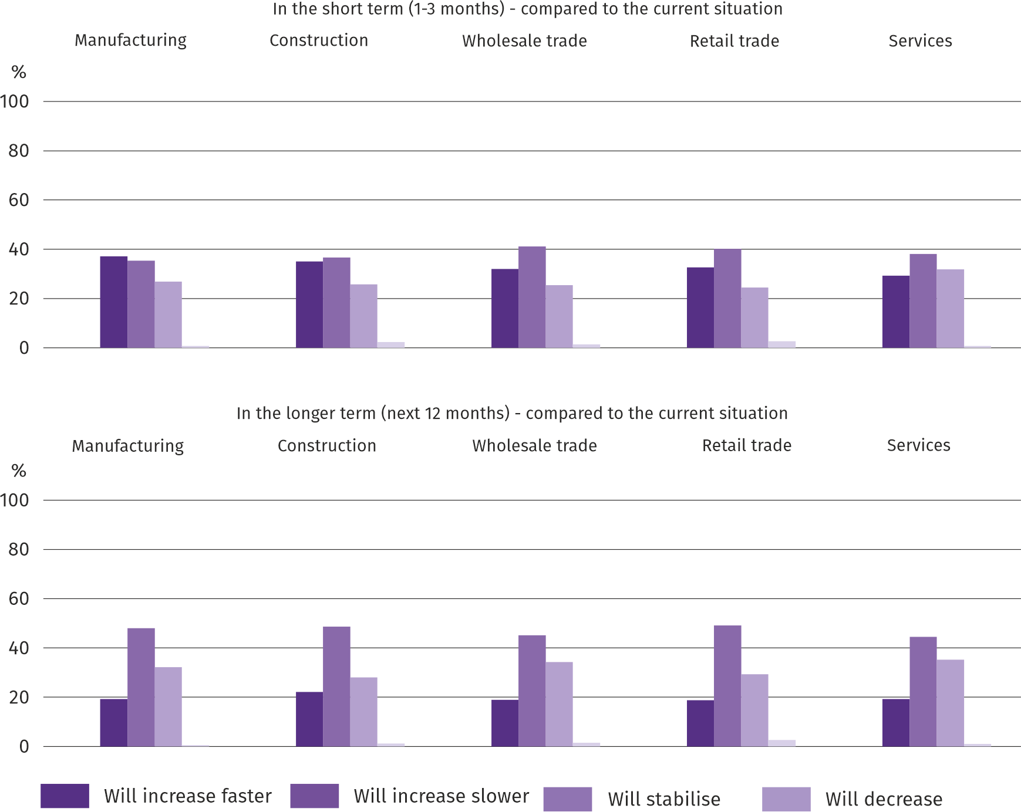
Question 4. What do you think the prices of services/materials/raw materials used by your company in its economic activities will be like?:

Entrepreneurs in most of the surveyed types of business most often believed that in a short period of time (1-3 months) prices will increase slower than currently; only in manufacturing there were the most opinions that they would grow faster. Anticipating price developments in the long term (the next 12 months), regardless of the type of economic activity, most entrepreneurs expressed the opinion that price growth will be slower than currently.

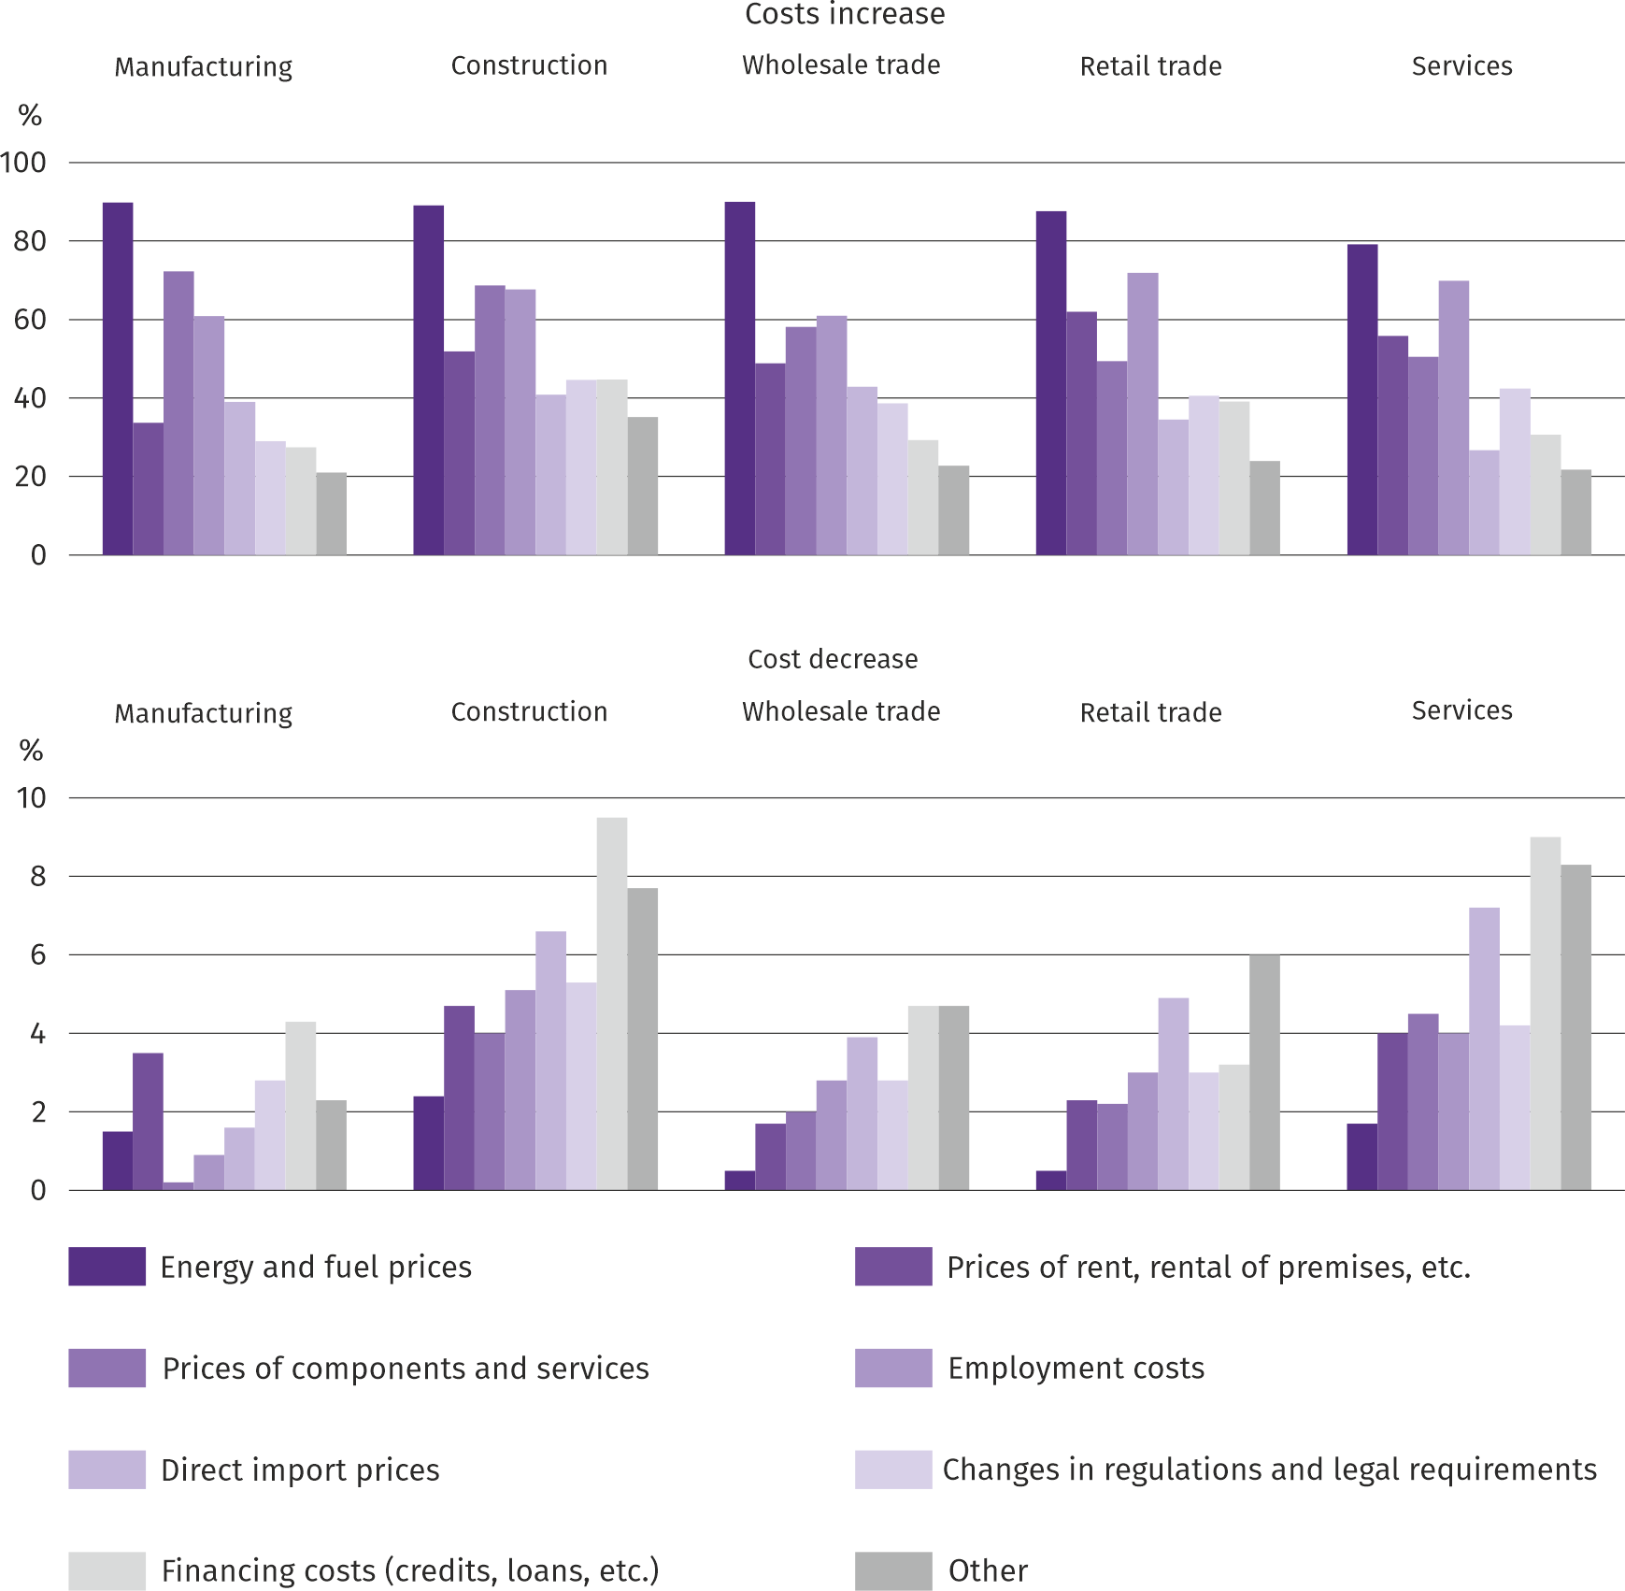
Question 5. Which of the following factors will have the greatest impact on your company's operating costs in the next quarter:

Entrepreneurs in all surveyed types of activity considered energy prices to be the factors having the greatest impact on the increase in the company's operating costs, followed by prices of components and services and employment costs. The factors that have the greatest impact on the decline in costs in all industries include financing costs (credits, loans, etc.), as well as prices of direct imports, and in manufacturing, prices of rent, premises, etc.

Question 6. Will the observed and predicted changes in the financing conditions of the enterprise (costs of bank loans and their availability, trade credit, deferred payments, etc.) result in, in the next 12 months, in the case of:
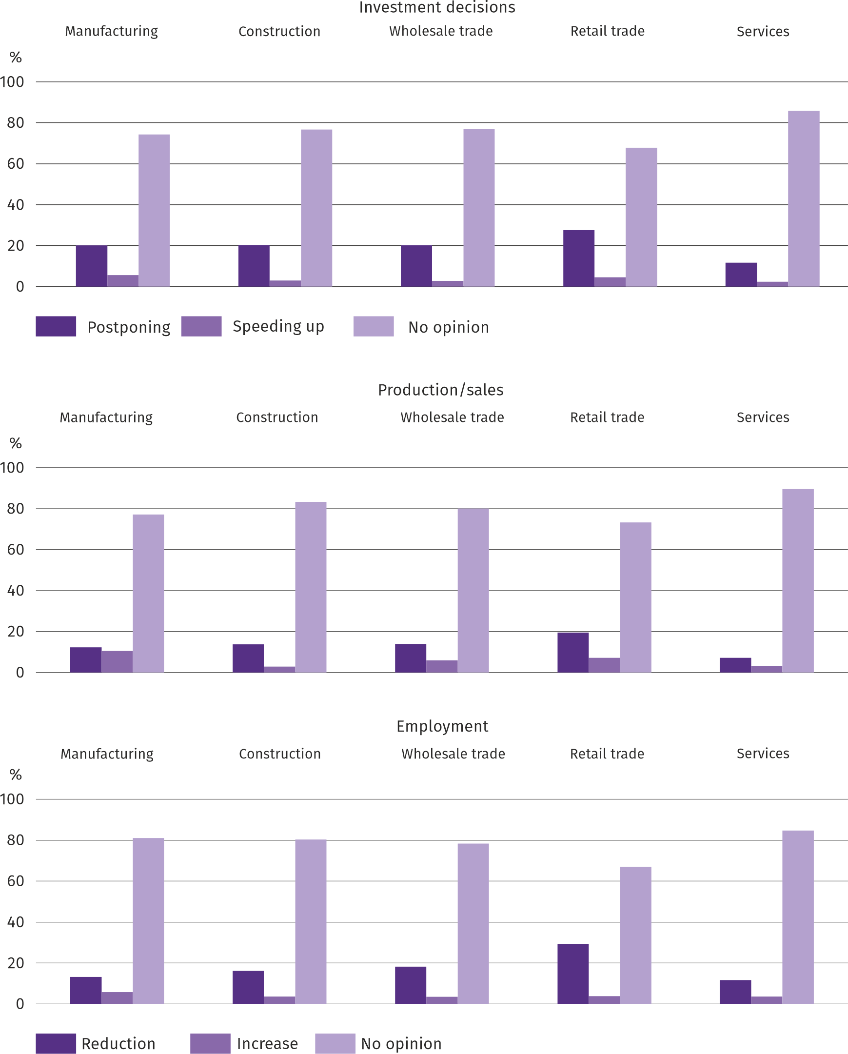
The answers to the questions about how the observed and expected changes in the company's financing conditions over the next 12 months will affect investment decisions, production/sales and employment indicate that it was difficult for entrepreneurs to assess this impact - the vast majority of respondents always had no opinion on this subject. Those who commented on the above-mentioned topic mostly expected postponement of investments, reduction of production/sales and employment rather than growth in the mentioned areas of activity.
More information on the results of the business climate survey can be found on the website of the Statistical Office in Zielona Góra https://zielonagora.stat.gov.pl/osrodki/osrodek-badan-koniunktury/obk-dane/.

Table 13. Selected data on Mazowieckie Voivodship
SPECIFICATION  A – 2025  B – 2026 |  | 01 | 02 | 03 | 04 | 05 | 06 | 07 | 08 | 09 | 10 | 11 | 12
Average employment in the enterprise sector ª  (in thousand persons) | A | 1582,5 | 1577,9 | 1572,7 | 1574,8 | 1570,6 | 1572,8 | 1574,1 | 1572,8 | 1571,5 | 1567,2 | 1570,8 | 1575,1
 | B | 1576,5 | 1573,2 | 1569,5
previous month=100 | A | 99,9 | 99,7 | 99,7 | 100,1 | 99,7 | 100,1 | 100,1 | 99,9 | 99,9 | 99,7 | 100,2 | 100,3
previous month=100 | B | 100,1 | 99,8 | 99,8
corresponding month of previous year=100 | A | 98,5 | 98,5 | 98,4 | 98,8 | 98,7 | 99,0 | 99,0 | 99,2 | 99,2 | 99,2 | 99,3 | 99,4
corresponding month of previous year=100 | B | 99,6 | 99,7 | 99,8
Registered unemployed persons (in thousand persons; as of end of period) | A | 114,7 | 115,9 | 113,9 | 111,3 | 108,7 | 111,0 | 116,0 | 120,2 | 119,6 | 118,7 | 118,1 | 118,2
 | B | 122,6 | 124,9 | 124,7
Unemployment rate b (in %; as of end of period) | A | 4,2 | 4,2 | 4,2 | 4,1 | 4,0 | 4,0 | 4,2 | 4,4 | 4,4 | 4,3 | 4,3 | 4,3
Unemployment rate b (in %; as of end of period) | B | 4,5 | 4,5 | 4,5
Job offers (submitted during a month) | A | 15760 | 13938 | 14768 | 13164 | 11459 | 4235 | 5656 | 4432 | 5028 | 4975 | 3612 | 2876
Job offers (submitted during a month) | B | 3327 | 4023 | 5549
Unemployed persons per 1 job offer (as of end of period) | A | 16 | 17 | 15 | 16 | 21 | 28 | 24 | 30 | 29 | 27 | 30 | 42
Unemployed persons per 1 job offer (as of end of period) | B | 39 | 36 | 27
Average monthly gross wages and salaries in the en-terprise sector ª (in PLN) | A | 9739,87 | 10004,89 | 10785,77 | 10612,28 | 9995,20 | 10173,45 | 10185,77 | 10100,98 | 9974,07 | 10141,45 | 10285,58 | 10933,28
 | B | 10345,31 | 10618,33 | 11502,04
previous month=100 | A | 98,1 | 102,7 | 107,8 | 98,4 | 94,2 | 101,8 | 100,1 | 99,2 | 98,7 | 101,7 | 101,4 | 106,3
previous month=100 | B | 94,6 | 102,6 | 108,3
corresponding month of previous year=100 | A | 108,9 | 109,2 | 108,4 | 110,9 | 109,2 | 109,4 | 107,7 | 106,9 | 108,0 | 105,3 | 108,5 | 110,1
corresponding month of previous year=100 | B | 106,2 | 106,1 | 106,6
Price indices:
consumer goods and services ^{c}:
corresponding month of previous year=100 | A | . | . | 104,7 | . | . | 103,7 | . | . | 102,6 | . | . | 102,3
corresponding month of previous year=100 | B | . | . | .
a In enterprises employing more than 9 persons. b Share of registered unemployed persons in civilian economically active population, estimated at the end of each month. C Since 1 June 2025, data on job offers are not fully comparable with earlier periods due to methodological changes resulting from the entry into force of the Act on theLlabour Market and Employment Services (Journal of Laws of 2025, item 620). d In the quarter.
Table 13. Selected data on Mazowieckie Voivodship (cont.)
SPECIFICATION  A – 2025  B – 2026 |  | 01 | 02 | 03 | 04 | 05 | 06 | 07 | 08 | 09 | 10 | 11 | 12
Price indices (cont.):
Procurement of cereal grain:
previous month=100 | A | 102,5 | 100,3 | 98,5 | 102,4 | 98,1 | 97,1 | 94,2 | 93,1 | 99,4 | 97,5 | 100,0 | 101,6
previous month=100 | B | 100,9 | 99,2 | 101,9
corresponding month of previous year=100 | A | 106,6 | 109,4 | 116,0 | 125,8 | 115,7 | 94,0 | 108,0 | 93,8 | 92,9 | 85,7 | 81,9 | 85,4
corresponding month of previous year=100 | B | 84,1 | 83,2 | 86,0
procurement of cattle for slaughter (excluding calves):
previous month=100 | A | 101,0 | 102,0 | 112,7 | 95,6 | 103,1 | 89,8 | 100,6 | 90,3 | 134,0 | 97,0 | 103,7 | 99,8
previous month=100 | B | 99,9 | 95,9 | 104,7
corresponding month of previous year=100 | A | 143,3 | 146,7 | 167,6 | 144,9 | 147,2 | 128,3 | 130,9 | 117,7 | 157,8 | 146,1 | 129,1 | 125,6
corresponding month of previous year=100 | B | 124,2 | 116,8 | 108,6
procurement of pigs for slaughter:
previous month=100 | A | 90,7 | 102,7 | 107,4 | 113,0 | 102,6 | 96,4 | 94,3 | 101,8 | 96,9 | 94,0 | 89,8 | 94,5
previous month=100 | B | 91,5 | 106,9 | 114,0
corresponding month of previous year=100 | A | 81,4 | 82,6 | 85,4 | 94,3 | 95,8 | 90,9 | 90,2 | 95,5 | 92,4 | 90,6 | 87,1 | 83,0
corresponding month of previous year=100 | B | 83,8 | 87,2 | 92,6
Ratio of procurement prices ª of pigs for slaughter to marketplace prices of rye | A | 7,7 | 7,7 | 8,3 | 9,9 | 9,7 | 9,2 | 8,4 | 9,4 | 9,3 | 8,7 | 8,0 | 7,7
 | B | 7,0 | 7,4 | 8,9
Sold production of industry ^{b} (at constant prices):
previous month=100 | A | 92,0 | 95,9 | 106,7 | 98,2 | 94,9 | 97,6 | 104,0 | 96,1 | 110,6 | 106,9 | 92,4 | 109,1
previous month=100 | B | 90,3 | 100,0* | 118,4
corresponding month of previous year=100 | A | 95,4 | 94,3 | 93,9 | 100,6 | 98,6 | 98,4 | 100,2 | 98,6 | 104,6 | 100,2 | 93,9 | 102,1
corresponding month of previous year=100 | B | 100,2 | 104,5* | 115,9
Construction and assembly production b (at current prices):
previous month=100 | A | 47,2 | 107,8 | 118,8 | 106,2 | 100,8 | 106,8 | 104,8 | 89,5 | 116,9 | 104,2 | 93,7 | 149,9
previous month=100 | B | 39,4 | 99,1 | 131,3
corresponding month of previous year=100 | A | 141,1 | 123,2 | 130,9 | 110,6 | 109,7 | 109,3 | 116,1 | 109,4 | 112,4 | 113,0 | 103,7 | 111,0
corresponding month of previous year=100 | B | 92,6 | 85,2 | 94,1
a Current prices excluding VAT. b In enterprises employing more than 9 persons.

Table 13. Selected data on Mazowieckie Voivodship (cont.)
SPECIFICATION  A – 2025  B – 2026 |  | 01 | 02 | 03 | 04 | 05 | 06 | 07 | 08 | 09 | 10 | 11 | 12
Dwellings completed (from the beginning of the year) | A | 3349 | 6879* | 9681* | 12469* | 16151* | 19593* | 23700* | 27265* | 30842* | 35358* | 38969* | 45020*
Dwellings completed (from the beginning of the year) | B | 2983 | 5939 | 9062
corresponding month of previous year=100 | A | 123,0 | 115,8* | 104,9* | 106,2* | 110,7* | 111,6* | 111,1* | 112,7* | 115,7* | 117,2* | 115,5* | 116,9*
corresponding month of previous year=100 | B | 89,1 | 86,3 | 93,6
Retail sales of goods ª (at current prices):
previous month=100 | A | 78,0 | 94,8 | 113,7 | 104,7 | 97,6 | 98,8 | 104,6 | 98,9 | 95,6 | 105,7 | 99,6 | 117,2
previous month=100 | B | 80,8 | 94,1 | 125,3
corresponding month of previous year=100 | A | 101,6 | 96,3 | 97,2 | 100,1 | 98,7 | 98,2 | 97,3 | 97,3 | 101,3 | 100,6 | 99,0 | 103,7
corresponding month of previous year=100 | B | 107,4 | 106,6 | 117,4
Turnover profitability indicator in enterprises ^{b}:
gross ^{c} (in %) | A | . | . | 4,6 | . | . | 4,9 | . | . | 4,9 | . | . | 5,1
gross ^{c} (in %) | B | . | . | .
net ^{d} (in %) | A | . | . | 3,6 | . | . | 3,9 | . | . | 4,0 | . | . | 4,2
net ^{d} (in %) | B | . | . | .
Investment outlays of enterprises ^{b} – from the begin-ning of the year (in million PLN; current prices) | A | . | . | 13471,2 | . | . | 31921,6 | . | . | 51529,6 | . | . | 80764,9
 | B | . | . | .
corresponding month of previous year=100 (current prices) | A | . | . | 99,7 | . | . | 106,8 | . | . | 106,4 | . | . | 106,6
corresponding month of previous year=100 (current prices) | B | . | . | .
Entities of the national economy ^{e} in the REGON regis-ter (as of end of period) | A | 1055182 | 1057965 | 1061558 | 1064898 | 1068064 | 1071074 | 1074082 | 1077325 | 1080871 | 1084899 | 1088107 | 1089830
 | B | 1090957 | 1093881 | 1097984
of which commercial companies | A | 237041 | 237949 | 239071 | 240155 | 240700 | 241451 | 242422 | 243409 | 696939 | 245130 | 246088 | 247076
of which commercial companies | B | 247914 | 248761 | 249824
Dwellings completed (from the beginning of the year) | A | 42461 | 42567 | 42726 | 42857 | 42903 | 43009 | 43119 | 43266 | 43348 | 43446 | 43570 | 43665
Dwellings completed (from the beginning of the year) | B | 43657 | 43697 | 43742
a In enterprises employing more than 9 persons. b In enterprises employing more than 49 persons. c Relation of gross financial result to revenues from total activity. d Relation of net financial result to revenues from total activity. e Excluding persons tending private farms in agriculture.
Prepared by:  Statistical Office in Warszawa  Director Agnieszka Ajdyn  Phone: (+48 22) 464 23 15 | Issued by:  Mazovian Centre for Regional Surveys  Statistical Information Centre  Mobile: (+48) 783 940 141
Press office in the Statistical Office in Warszawa  Mobile: (+48) 783 940 141  e-mail: m.kaluski@stat.gov.pl |   warszawa.stat.gov.pl/en/

@Warszawa_STAT

@UrzadStatystycznywWarszawie

gus_stat

glownyurzadstatystycznygus

glownyurzadstatystyczny

In the case of quoting data from the Statistics Poland, please provide information “Statistics Poland data source”, and in the case of publishing calculations made on data published by the Statistics Poland, provide information: “Own study based on Statistics Poland data”.
Related information
Statistical Bulletin of Mazowieckie Voivodship
Report on the socio-economic situation of Mazowieckie Voivodship 2025
Socio-economic situation of voivodships No. 4/2025
Data available in databases
Local Data Bank (BDL)
Knowledge Databases (DBW)
Terms used in official statistics
Average paid employment
Registered unemployed persons
Registered unemployment rate
Monthly gross wages and salaries
Retail prices
Price index of consumer goods and services
Procurement of agricultural products
Procurement prices
Marketplace prices
Pigs
Cattle
Sold production of industry
Construction and assembly production
Dwellings completed
Retail sales of goods (including VAT)
Wholesale (including VAT)
Financial results of enterprises
Investment outlays
Entities of the national economy
Business tendency

Refers to vacancies and places of occupational activation.
The average values ​​of temperature and precipitation were calculated as arithmetic means of the average monthly values ​​from five hydrological and meteorological stations of the Institute of Meteorology and Water Management located in Kozienice, Mława, Płock, Siedlce and Warszawa.
It applies to legal persons, organisational units without legal personality and natural persons conducting economic activity (excluding natural persons tending private farms in agriculture).
The survey was conducted from 1 to 10 of a current month, on a sample of industrial, construction, commercial and service units. The questions were divided into two sections - questions about the impact of the war in Ukraine on the economic situation and questions about price processes. Answers to the entire additional block of questions are provided on a voluntary basis. In all questions, the percentage of respondents' answers to a given variant is presented. The data has been aggregated in accordance with the aggregation (weighting) methodology used as standard in the study of the economic situation.
It was permissible to select one answer for each option ("outflow" and "inflow") simultaneously, therefore the sum of the options may exceed 100%. The answer "not applicable" was selected if the company did not employ workers from Ukraine or had not observed any outflow or inflow of workers in the previous month.

