Information about the Statistical Office in Kraków in easy-to-read text

The Statistical Office in Kraków is located at 3 Kazimierza Wyki Street.

We have branches in these cities:
• The branch in Chrzanów is at 16 Rynek Street
• The branch in Nowy Sącz is at 52 Jagiellońska Street
• The branch in Tarnów is at 2 Kazimierza Wielkiego Square
• The branch in Zakopane is at 7 Jagiellońska Street
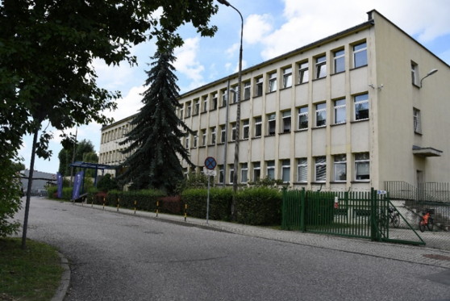

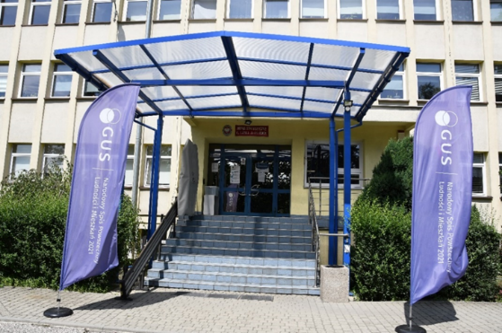

Our Office is headed by a Director. The Director of the Statistical Office in Kraków is Ms Agnieszka Szlubowska.

The Director is assisted in his work by his deputy and the Office’s staff. The Deputy Director of the Statistical Office in Kraków is Mr Grzegorz Ruta.

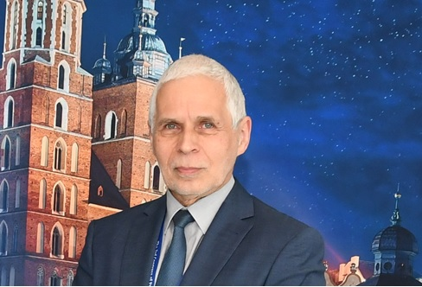

What we do?

Our office collects and studies information about people and life. Anyone can look at our numbers. Our work helps people see and understand important issues. We use clear numbers and simple words so you can easily understand the facts.
Our Office organize censuses and other important statistical surveys. A huge national survey, organize every 10 years, is called a census. In this survey, we collect data from all Poles living in Poland and Poles living in other countries.
Our workers visit homes or call random people to ask them questions. We spend a lot of time studying the Małopolska region.
We partner with schools, universities and government offices.
We help leaders decide. We give important facts to the government so they can make good decisions for everyone.

The Office keeps two important official lists: the REGON Register and the TERYT Register:
- REGON Register is a list of all businesses and institutions in Poland. Every business gets a unique ID number called a REGON number. This number tells you where a business is and what it does.
- TERYT Register is a list of all cities, towns, and streets in Poland. Every place and street gets its own ID number called a TERYT identifier. Officials use these numbers to fill out forms and track locations

What you can do at our Office:
- get or update your business ID number (REGON)
- find official numbers and statistics
- learn about our official statistical reports and publications
- read statistical books and papers for free

Contact us:
- send a letter to:
Statistical Office in Kraków, 3 Kazimierza Wyki Street, 31-223 Kraków
- call us. Dial 12 42 04 510 or 12 42 04 050. Find more phone numbers on our website
- send an email. Write to sekretariatUsKRK@stat.gov.pl
- use e-PUAP. Send an online message to our address: /54d90bmpuh/
- come in person

There is a disabled parking space in front of the entrance. | 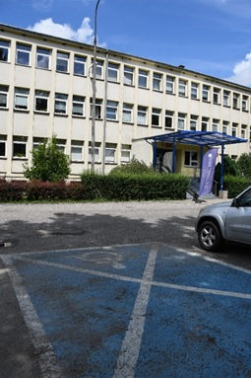
To the left of the stairs is a stair lift (a device for wheelchair access). | 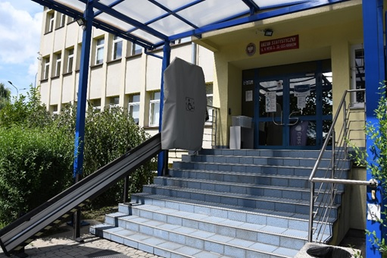
The bell for the stair lift, used to summon staff, is located to the right of the stairs. | 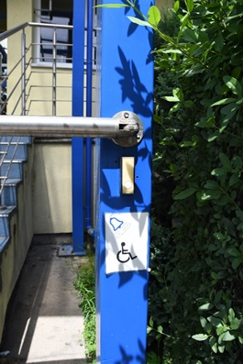
Enter through the main entrance.  To the left of the entrance is the registration desk. Next to it is the REGON service counter. You can sort out all your business on the ground floor in the Customer Service Centre. | 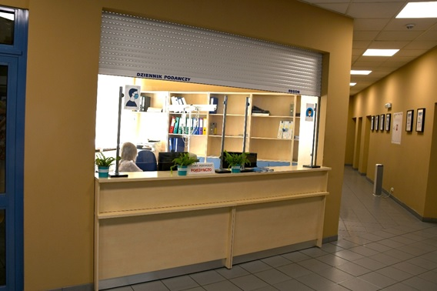
The toilet for people with disabilities is on the ground floor. | 
You can ask for a sign language interpreter to help you at the Office. Tell us 3 days before your visit if you need an interpreter. | 

